Question 1

//Q1

#include<math.h>

#include<iostream>

using namespace std;

int add(int a,int b){

return a+b;

}

int sub(int a,int b){

return a-b;

}

int division(int a,int b){

return a/b;

}

int mul(int a,int b)

{

return a*b;

}

int power(int a,int b){

int r=pow(a,b);

return r;

}

int main(){

int choice;

do{

cout<<"1.Add\n";

cout<<"2.sub\n";

cout<<"3.mul\n";

cout<<"4.div\n";

cout<<"5.pow\n";

cout<<"0.Exit\n";

cout<<"Enter the choice";

cin>>choice;

switch(choice){

case 1:{

int a,b;

cout<<"Enter a:";

cin>>a;

cout<<"Enter b";

cin>>b;

int r=add(a,b);

cout<<"Sum is :"<<r<<"\n";

break;

}

case 2:{

int a,b;

cout<<"Enter a:";

cin>>a;

cout<<"Enter b";

cin>>b;

int r=sub(a,b);

cout<<"Sub is :"<<r<<"\n";

break;

}

case 3:{

int a,b;

cout<<"Enter a:";

cin>>a;

cout<<"Enter b";

cin>>b;

int r=mul(a,b);

cout<<"Mul is :"<<r<<"\n";

break;

}

case 4:{

int a,b;

cout<<"Enter a:";

cin>>a;

cout<<"Enter b";

cin>>b;

try{

if(b<=0){

throw " Base must be greater than zero";

}

//if exception not get throw then this code will execute

int r=division(a,b);

cout<<"Div:"<<r<<"\n";

}catch(const char* e){

cout<<e<<"\n";

}

break;

}

case 5:{

int a,b;

cout<<"Enter a:";

cin>>a;

cout<<"Enter b";

cin>>b;

try{

if(b<=0){

throw " Base must be greater than zero";

}

//if exception not get throw then this code will execute

int r=power(a,b);

cout<<"Power:"<<r<<"\n";

}catch(const char* e){

cout<<e<<"\n";

}

break;

}

case 0:{

cout<<"Exit!!";

break;

}

default:{

cout<<"invalid inputs!!";

break;

}

}//out of switch

}while(choice!=0);

return 0;

}

o/p

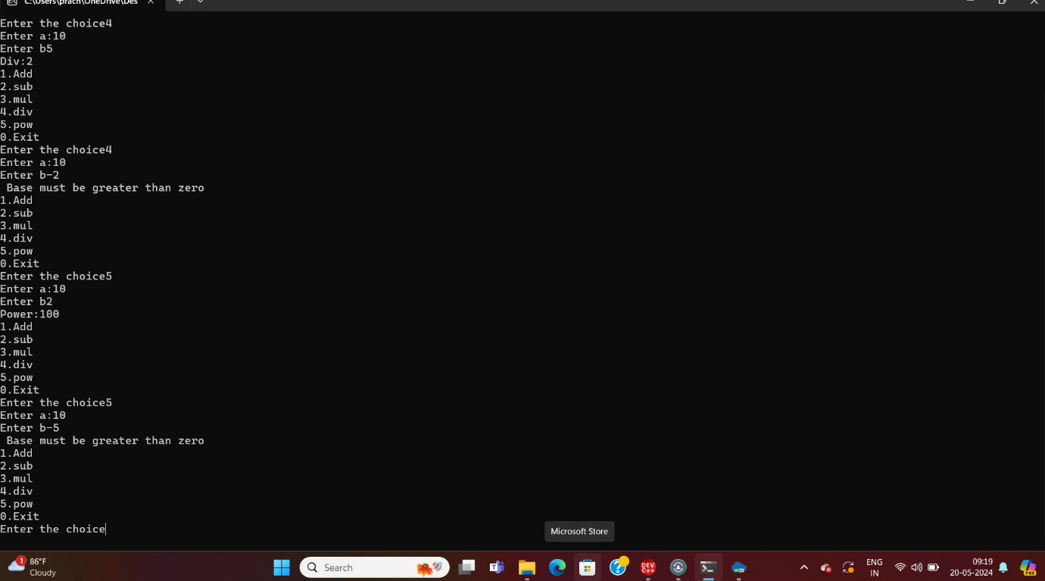

Q2

#include<iostream>

using namespace std;

class Acount{

int acNum;

double balance;

static int count ;

public:

Acount(){

this->acNum=count;

this->balance=0;

Acount::count++;

}

Acount(int b){

this->acNum=count;

this->balance=b;

Acount::count++;

}

void setBalance(double b){

this->balance=b;

}

double getBalance(){

return this->balance;

}

static int getcount(){

return Acount::count;

}

void display(){

cout<<"Account:\n";

cout<<"Ac_num:"<<this->acNum<<"\n";

cout<<"Balance:"<<this->balance<<"\n";

cout<<"Account count::"<<Acount::count<<"\n";

}

double deposite(double amt){

this->balance=this->balance+amt;

return this->balance;

}

double withdraw(double amt){

this->balance=this->balance-amt;

return this->balance;

}

};

int Acount::count=0;

int main(){

cout<<Acount::getcount();

Acount a;

a.display();

cout<<Acount::getcount();

Acount b(300);

b.display();

cout<<Acount::getcount();

Acount c(700);

c.display();

c.deposite(300);

double r=c.withdraw(200);

cout<<"After withdraw balance:"<<r;

return 0;

}

o/p

